HMS
Admissions, Discharges, Transfers

Version: 1.0
Effective Date: 24 / 04 / 2013

Document History
 | Prepared By | Reviewed By | Approved By
Name
Designation | Senior business Analyst |  | Associate Product Manager
Signature

- Contents
Document History 2
Revision History 2
1.1 Admission Advice 9
1.2 Edit/Cancel/Confirm Admission Advice 12
1.3 Bed Reservation 19
1.4 Edit/Cancel/View Reservation 24
1.5 Process Admission 27
1.6 Edit/Cancel/View Admission 36
1.7 Transfer Request 40
1.8 Bed Transfers 44
1.9 Cancel /View Bed Transfers 49
1.10 Discharge Advice 52
1.11 Discharges 55
1.12 Edit / Cancel/View Discharge 61
1.13 Bed Status Management 65
1.14 Change Doctor Request 68
1.15 Edit / Cancel /ViewChange Doctor 70
1.16 Discharge Summary 73
1.17 Edit / Cancel / Verify/Handover Discharge Summary/Print 79
1.18 Admission Output Generation 84
1.19 Swap patient Beds 89
1.20 ADT Work Area 93

Admission and Transfer Process

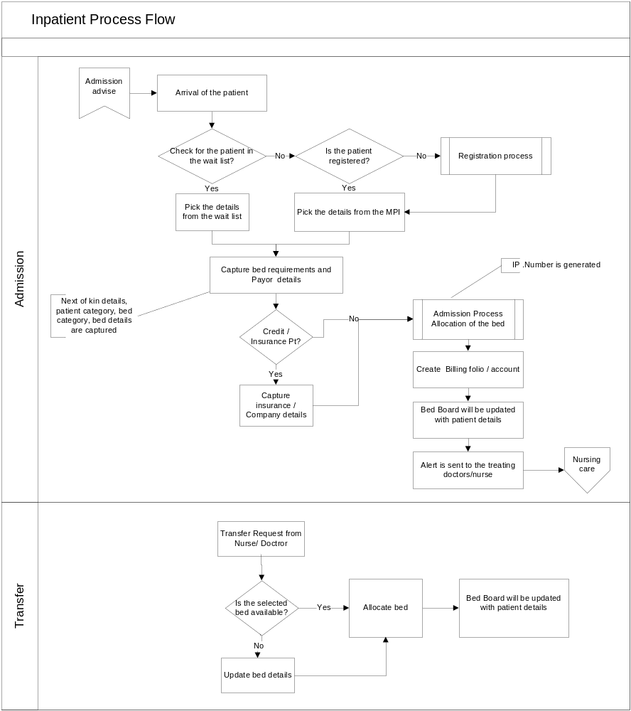

Discharge Process

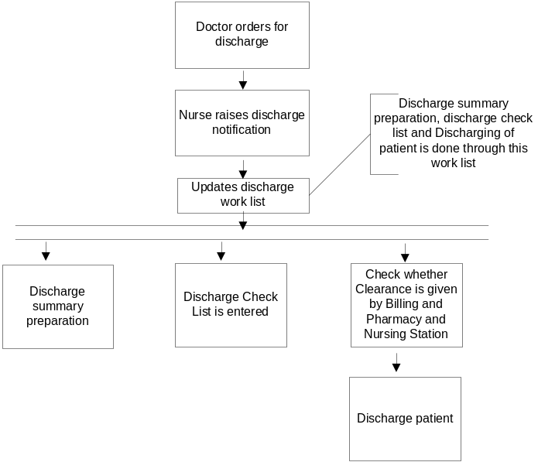

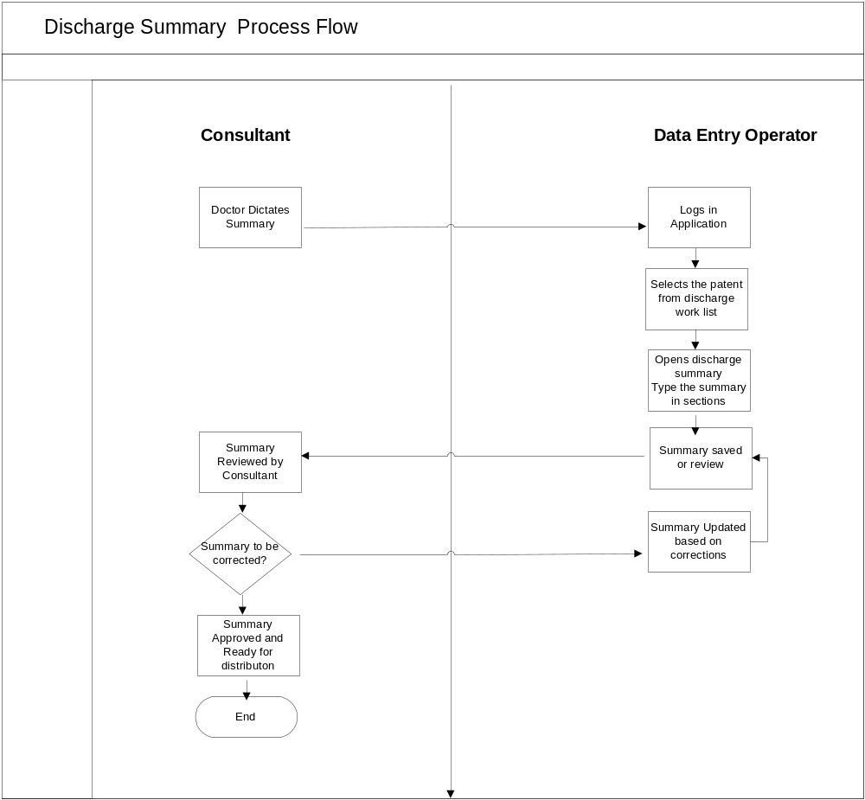

Site Map

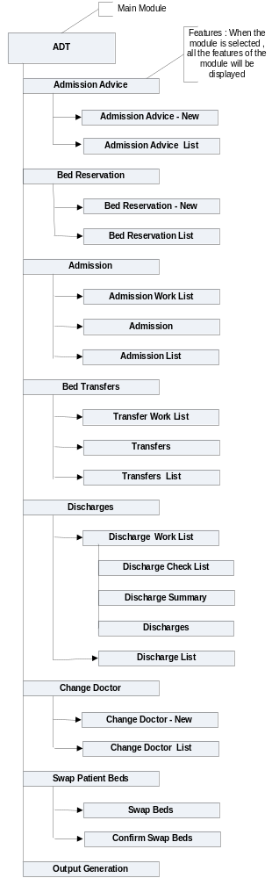

Admission Advice

Use Case ID: | UC# FID_ARQ_0001_UC _ 001 |  | Feature#: FID_ARQ_0001 |  | PRD# :
Use Case Name: | Admission Advice
User Story: | Doctor after evaluation of the patient during the process of consultation, suggests that the patient needs admission to the hospital for better care. To initiate the process of admission, doctor raises the admission advice in the system to provide information to the ADT and other concerned department/stakeholders for planning and executing their respective responsibilities.  Doctor explains to the plan of care and probable length of the stay in the hospital and captures the same along with admission advice.
Created By: | Latha Patel | Last Updated By:
Date Created: | Apr 25, 2013 | Date Last Updated:

Actors: | Primary: Physicians, Secondary: ADT staff
Description: | This process allows the doctor to advice for admission of their patients, captures the reason for admission, expected length of stay
Trigger: | Admission advice screen is launched from CPOE and ADT
Preconditions: | - The patient has either a valid appointment for consultation or is a walk-in in the OP or Casualty / Emergency department  - D  emographic details of the patient as applicable to the type of appointment / Admission are available (Patient Banner details are populated on Page Load)  - The patient details are populated in the patient queue of the concerned clinician  - All the masters required for Admission advice shall be available
Post conditions: | Admission work list will be populated with admission advices  In case ADT staff raises request , it shall be displayed in Admission Work List only after confirmation
Normal Flow: | - Physician(Primary Actor): Enter Admission Advice details and clicks Submit  - System Response: update Admission Advices list.
Alternative Flows: | - Physician (Primary Actor): writes the Admission Advice on paper  - ADT staff (Secondary Actor): Enter admission request details in the system, clicks Save  - System Response:  - a. Update Admission advice details in the Admission Advice list.  - b. Update Admission advice details in Admissions Work List
Exceptions: | NA
Includes: | NA
Priority: | Medium
Frequency of Use: | Frequently used
Business Rules: | - Admission requests can be made after the Registration only.  - Once request is made, admission work list will be updated.  - Admission advice cannot be cancelled after the admission  - Patient category and provisional diagnosis is displayed if captured in previous transactions .else/ needs to be captured here. If captured previously further editing can be done here .  - Patient category and provisional diagnosis captured for the current encounter /episode are displayed  - Sub service is populated based on the hospital service  - Admission Advice for the same period shall not be allowed.
Special Requirements: | New Mode : Editable or Non Editable Fields  Admitting Doctor –Combo - Selection from masters  Specialty –Combo Displayed based on doctor  Admission Type – Combo - Selection from masters  Patient Category – Combo - Selection from masters  Hospital Services –Combo - Selection from masters  Sub Service –Combo - populated based on Hospital service (If service is selected then sub service is mandatory )  Provisional Diagnosis –Search Screen - Selection from masters  Expected Date and Time of Admission –Date and Time picker – By default current date / time . It should not be lesser than current date  Expected length of stay – Entry  Bed Reservation Required – Check box Selection  Remarks –Text Area - Entry
Assumptions: | NA
Notes and Issues:
(NFR #List) Non-functional Requirements | NA
Screen Name with Pattern Mapping | Admission Advice – UIP 13 and Patient Search UIP04
Messages (Error / Status Messages ) | Status Messages – On Save - Record inserted /updated successfully  Error Messages –on Save - Record Not inserted /updated  “ Expected Date /Time of admission shall not be lesser than current date “
Break crumb Details | Home - ADT – Admission Advice
Collapsible Panels | NA
Configurable Fields (Display / Not to Display) | NA

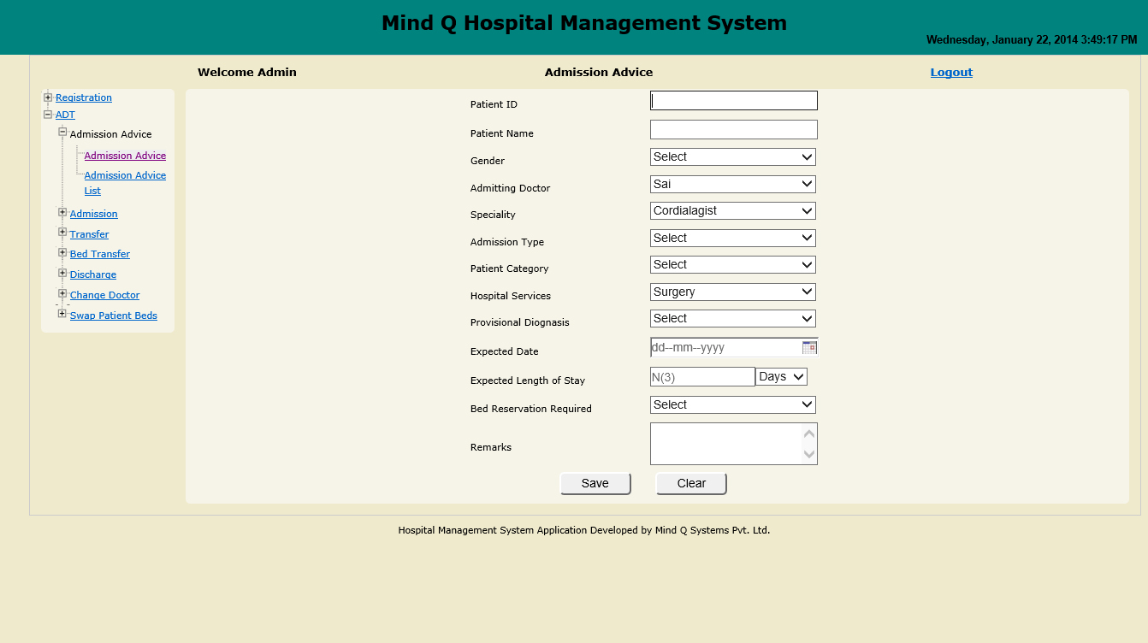

Edit/Cancel/Confirm Admission Advice
Use Case ID: | UC# FID_ARQ_0001_UC _ 002 |  | Feature#: FID_ARQ_0001 |  | PRD# :
Use Case Name: | Edit / Cancel/Confirm
User Story: | Doctor wants to confirm the admission request raised by ADT staff
Created By: | Nagesh | Last Updated By:
Date Created: | Apr 25, 2013 | Date Last Updated:

Actors: | Primary: Doctor; Secondary: ADT Staff
Description: | This process is used edit / cancel /confirm the admission advice
Trigger: | Admission Advice List is launched from top panel
Preconditions: | Admission advice should have been done
Post conditions: | Admission advice shall be updated and displayed in the Admission work list  And also in the Admission Advice List
Normal Flow: | ADT Staff (Secondary Actor): Selects the patient and raises the admission advice on doctor’s behalf  This advice has to be authorized by the doctor
Alternative Flows:
Exceptions: | NA
Includes: | NA
Priority: | High
Frequency of Use: | Frequently used
Business Rules: | - List shall display only the current day advices on page load  - Selection of the row and click on the Edit button shall allow to edit the advice details. Refer the screen Admission Advice – Edit  - Selection of the row in the list and click on the view shall display the captured details. Refer the screen Admission Advice – View  - Selection of the row in the list and click on the Cancel shall display the screen in cancel mode to capture the Reason for Cancellation, (Cancellation indicated by different colour code-complete row).  - If the details are updated, the pop up message “Advice Details of <<Patient Name>> updated successfully”.  - If advice is raised by ADT staff , it has to be confirmed by the doctor  - If the advice raised by doctor , then advice need not be confirmed  - The system shall not allow cancellation of advice once admission is done against that advice.  - User shall not be allowed to edit details through the Advice List once the patient is admitted.  - Realization of Advice is indicated through the change in status / colour in the list.  - Notification shall be sent to the doctor if any changes/cancellation of advice done by the ADT staff  - After confirmation user can edit/cancel admission advice  - After admission the status of the record in the admission list shall be updated to “Admitted”  - The status are Pending/Cancelled/Confirmation / Admitted
Special Requirements: | Edit Mode – Patient Banner Details shall not be editable  Other fields can be edited  Cancel Mode:  All the fields are Non Editable  User needs to capture Reason For Cancellation  View Mode – All fields re non editable . If user selects Cancelled record , cancellation reason shall be shown  Confirm – All the fields are Non Editable
Assumptions: | NA
Notes and Issues:
(NFR #List) Non-functional Requirements | NA
Screen Name with Pattern Mapping | Admission Advice List – UIP08and Patient Search UIP04  Admission Advice in Edit Mode – UIP13  Admission Advice in Cancel Mode – UIP13  Admission Advice in View Mode – UIP13  Admission Advice in Confirm Mode – UIP13
Messages (Error / Status Messages ) | Status Messages – On Save - Record inserted /updated successfully  Error Messages –on Save - Record Not inserted /updated  “ Expected Date /Time of admission shall not be lesser than current date “
Break crumb Details | Home - ADT – Admission Advice List  Home – CPOE – Admission Advice List
Collapsible Panels | NA
Configurable Fields (Display / Not to Display) | NA

Fig : Admission Advice List
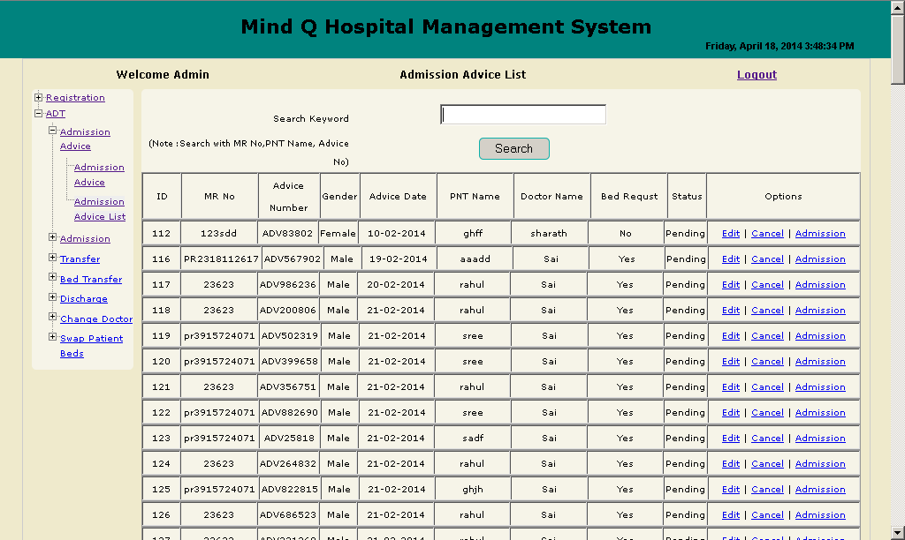

Figure : Admission Advice – Edit
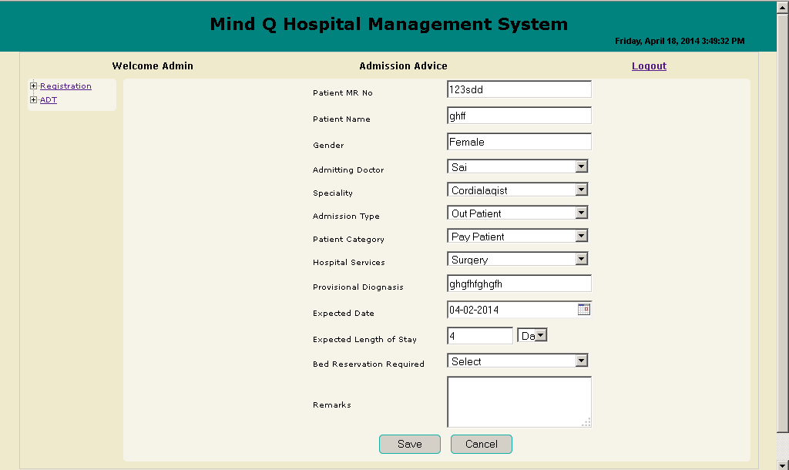

Figure : Admission Advice – Cancel Mode

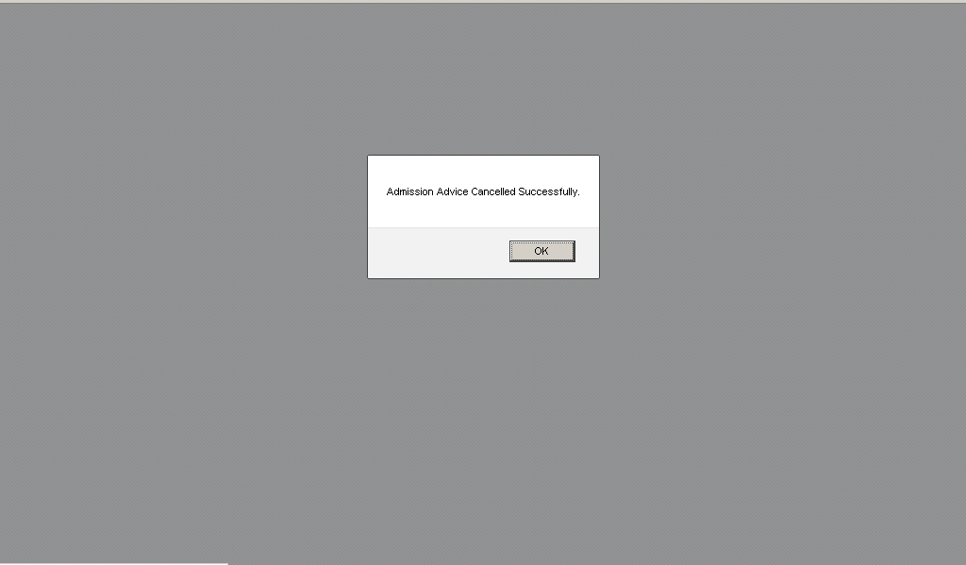

Figure : Admission Advice – View
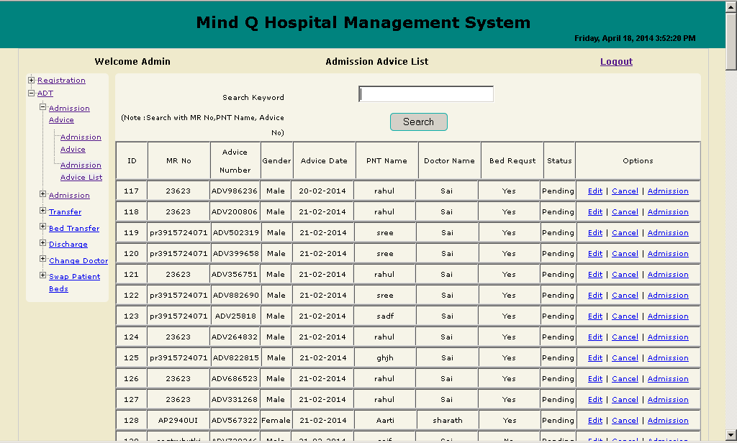

Bed Reservation

Use Case ID: |  | UC#FID_BED_0001_UC _ 001 |  | Feature#:FID_BED_0001 |  | PRD# :
Use Case Name: |  | Make Bed Reservation– Accommodation for Registered patient Non Registered patients
User Story: |  | Patient would like to reserve bed. ADTstaff responsible for the reservations of beds. ADT Staff has to reserve the bed for a patient on receipt of telephonic, fax, in person or any other agreed format of reservation request
Created By: |  |  | Last Updated By: |  | Nagesh
Date Created: |  | Apr 24, 2013 | Date Last Updated:
Actors: | Primary : Patient; Secondary : ADT staff
Description: | - Allows the ADT user to book the bed for current and future date up to a limit specified by the Hospital policy.(App config)  - . The ADT staff have to reserve beds ranging in terms of General reservation which is only an indicator of a reservation requirement , where in no specific ward, class or bed is identified against reservation, User can block specific ward, bed class or bed as identified by the patient
Trigger: | Bed Reservation screen is launched from ADT
Preconditions: | - Patient Search Facility / Component shall be made available to enable verification if the patient is registered.  - Bed Availability chart should be available for reserving the beds  - All the masters required for bed reservation shall be available. (Refer ADT Master excel sheet for the masters)
Post conditions: | - Saved Bed reservation details shall be available for use at the time of /in the context of actual admission as part of Admission work list.  - Bed reservation details shall update the bed reservation list
Normal Flow: Registered Patient Reservation Flow | - ADT Staff (Secondary Actor): Enter Patient Identifiers and Click Search  - System Response : Validate Patient IdentifiersDisplay a list of registered patients confirming to search parameters for the given identifiers  - ADT Staff (Secondary Actor): Identifies & double clicks on the patient row to Select the patient.  - System Response: Display “Bed Reservation ” and Patient details are displayed in the Patient Banner  - ADT Staff (Secondary Actor): Enter details and Click “Save”  - System Response: Validate reservation requirement and display the result as per availability  - System Response: Generate a unique booking number  - Update Admission Work List
Alternative Flows: Non Registered patient Reservation flow | - ADT Staff (Secondary Actor): Enter Patient Identifiers and Click Search  - System Response : Validate and Display result  - ADT Staff (Secondary Actor): Clicks on Non-Registered patients  - System Response: Display “Reservation form for Nonregistered Patients”  - Patient banner will not be displayed. In Place of Patient Banner the following fields are displayed  - Patient Name (Entry )  - Age (Entry)  - Gender (Selection )  - Patient Class (Selection)  - ADT Staff (Secondary Actor): Enter details and Click “Save””  - System Response: Validate reservation requirement and display the result
Exceptions: | NA
Includes: | NA
Priority: | High
Frequency of Use: | Frequently used
Business Rules: | - Bed Reservation is allowed for Registered and Non registered patients  - In case of Non registered patients , following details are mandatory  Name , Age , Gender and Patient Class  - Bed Reservations shall not be allowed for past dates.  - Reservation of the ward, bed class and bed is possible. (appconfig).  - →Case1: Reservation as per any bed class across any applicable ward.(If bed class is selected , nursing station shall be populated wherever the selected bed class is available)  - →Case 2: Reservation as per specific bed class in a specific ward  - →Case3: Reservation of a specific bed(Block)  - If configuration is only for bed class, nursing station , ward /beds will not be displayed. If configuration is for ward , bed details will not be displayed. If configuration if for bed , all the details will be displayed . if block bed is checked , user needs to select the bed , from date .  - If LOS is captured Bed will be blocked for those many days .Otherwise bed will be blocked only for that day User can link the billing policy  - Once the Bed Reservation is done, a booking is generated. The details shall be shown in the Admission Work List .  - If patient does not arrive xxx hours prior to or within xxx hours(Appconfig) of promised arrival on the date (time overlap across dates have to be taken care of) of Admission the reservation shall stand cancelled.  - Once the transaction is saved the system shall display a message to print the output configured i.e. a bed reservation slip along with a standard disclaimer shall be generated. – De – Scoped for current sprint  - User shall be able to track whether bed reservation is auto cancelled or cancelled by the user  - Bed class to be populated based on Patient Class (App .Config).  - Isolated beds shall not be available for selection (App.Config)  - Blocked beds shall not be available (App config)  - Availability of vacant beds based on expected date of discharge (App.config)  (Expected date of discharge is auto calculated based on Expected date of admission and Length of Stay)  - Referral Details – Referred By (Refer to the section Referral Details of Admission)  - If user clicks Save , user will be navigated back to Bed Reservation List screen. If user clicks “Save & New “ , the focus stays in the same page  - Communications: De- scoped for current sprint  - The system shall communicate the status of reservation on a predefined period basis to all the concerned stake holders like patient, Staff, doctors through predefined communication systems  - The system shall communicate the arrival of the patient for admission to all the concerned stake holders through predefined communication systems  - The system shall communicate the non-arrival of admission / cancellation of admission to all the concerned stake holders through predefined communication systems
Special Requirements: | New Mode : Editable or Non Editable Fields  For Registered Patients  Registered – By Default it is selected  Patient ID – Non editable . Displayed based on selection from the help Screen  Patient Banner – Non Editable  Admission Details :  Admitting Doctor – Combo - : Selection from masters  Specialty – Combo -Non Editable ( Displayed based on doctor)  Expected Date and Time of Admission –Date/ Time Picker - Entry-  Expected Length of Stay – Text box With Combo - Entry  Bed Class – Combo - Selection from masters (Populated based on Patient Class. App Config))  Nursing Station –Combo - Selection from masters ( Populated based on Bed Class)  Ward –Combo – Selection from masters (Populated based on Nursing Station)  Block Bed – Check Box Selection (On default it should be unchecked)  Grid –Non Editable ( Is populated based on Ward)  Bed – Non Editable (Populated based on selection in the grid)  From Date – Selection from date picker ( Should not be greater than Admission date and Lesser than Requested Date )  Reason for Admission – Selection from masters  Remarks – Entry  For Non Registered Patients  Non Registered – Radio button Selection  Patient ID and Patient Banner will not be displayed  Following fields are visible :  Patient Name –Text Box - Entry (Mandatory)  Age – Text Box - Entry  Gender – Combo - Selection from masters  Patient Class – Combo - Selection from masters  Admission Details are same as in the above section  Admitting Doctor : Selection from masters  Specialty – Non Editable ( Displayed based on doctor)  Expected Date and Time of Admission – Entry  Expected Length of Stay – Entry  Bed Class – Combo - Selection from masters (Populated based on Patient Class. App Config))  Nursing Station –Combo - Selection from masters ( Populated based on Bed Class)  Ward –Combo – Selection from masters (Populated based on Nursing Station)  Block Bed – Check Box Selection (On default it should be unchecked)  Grid –Non Editable ( Is populated based on Ward)  Bed – Non Editable (Populated based on selection in the grid)  From Date – Selection from date picker ( Should not be greater than Admission date and Lesser than Requested Date )  Reason for Admission – Selection from masters  Remarks – Entry
Assumptions: | NA
Notes and Issues:
(NFR #List) Non-functional Requirements | NA
Screen Name with Pattern Mapping | Bed Reservation – UIP13 and Patient Search UIP04
Messages (Error / Status Messages ) | Status Messages – On Save - Record inserted /updated successfully  Error Messages –on Save - Record Not inserted /updated
Breakcrumb Details | Home - ADT – Bed Reservation
Collapsible Panels | Referral Details ( The details are captured in the registration ) Same details shall be shown on Panel expansion
Configurable Fields (Display / Not to Display) | When Registered is selected not to display the following fields  Patient Name – Entry (Mandatory)  Age – Entry  Gender – Selection  Patient Class – Selection  When Non Registered , Patient ID and Banner shall not be displayed

For Registered Patients follow the below figure
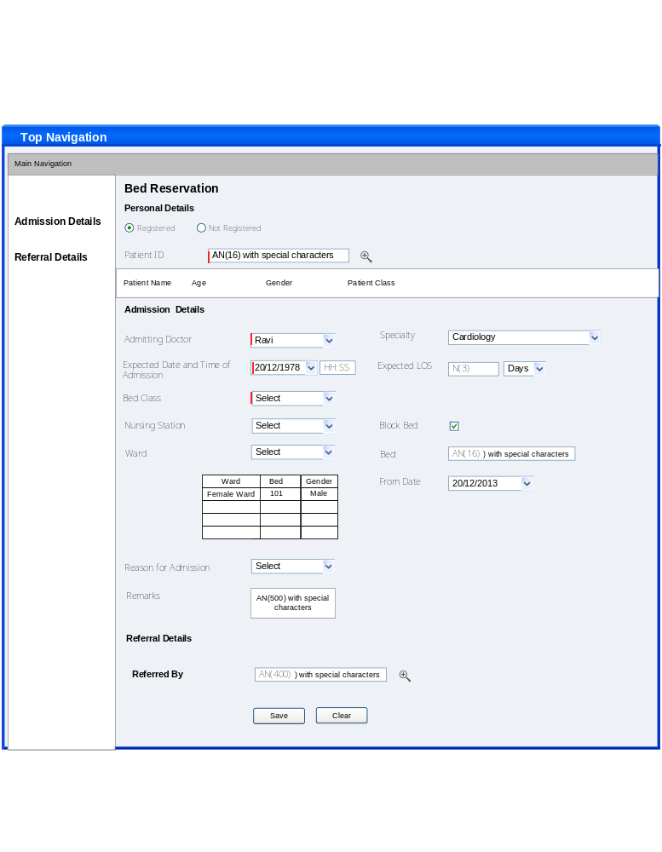

For Non Registered Patients
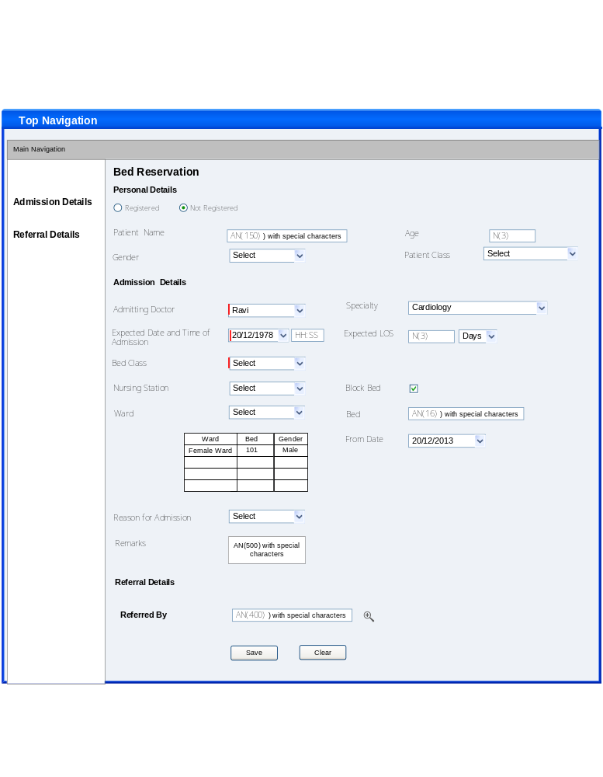

Edit/Cancel/View Reservation
Use Case ID: | UC# FID_BED_0001_UC _ 002 |  | Feature#: FID_BED_0001 |  | PRD# :
Use Case Name: | Edit / Cancel /View Reservation-
User Story: | Patient wants to cancel the bed reservation
Created By: | Latha Patel | Last Updated By:
Date Created: | Apr 25, 2013 | Date Last Updated:

Actors: | Primary: Patient; Secondary: ADT Staff
Description: | This process is used edit / cancel/view the bed reservation
Trigger: | Bed reservation List is launched from top panel
Preconditions: | Bed reservation should have been done
Post conditions: | Bed reservation details shall be updated and displayed in the Bed Reservation list
Normal Flow: | ADT Staff (Secondary Actor): Selects the patient and click on Cancel  System Response : Displays pop screen and prompts to capture Cancelled By reason and Cancelled by , Date /Time
Alternative Flows:
Exceptions: | NA
Includes: | NA
Priority: | High
Frequency of Use: | Frequently used
Business Rules: | - List shall display only the current day Reservations on page load  - Selection of the row and click on the Edit button shall allow to edit the Reservation details.  - Selection of the row in the list and click on the view shall display the captured details.  - Selection of the row in the list and click on the Cancel shall display the screen in cancel mode to capture the Reason for Cancellation, (Cancellation indicated by different colour code-complete row.  - If the details are updated, the pop up message “Reservation Details of <<Patient Name>> updated successfully”.  - . Only the date, time , ward, consultant and class details can be edited.  - The system shall not allow cancellation of Reservation once admission is done against that reservation.  - User shall not be allowed to edit details through the Reservation List once the patient is admitted.  - Realization of Reservation is indicated through the change in status / colour in the list.  - System shall not allow duplicate reservation of beds for the same patient for the same period.  - System shall allow reservations for different period.
Special Requirements: | Edit Mode : Editable or Non Editable Fields  For Registered Patients  All the below fields are selected from the list and Non editable  Registered –  Patient ID – Non editable . Displayed based on selection from the help Screen  Patient Banner – Non Editable  Admission Details :  Admitting Doctor : Selection from master – Editable  Specialty – Non Editable ( Displayed based on doctor)  Expected Date and Time of Admission – Entry  Expected Length of Stay – Entry  Bed Class – Selection from master (Populated based on Patient Class . App Configuration)  Bed Class – Combo - Selection from masters (Populated based on Patient Class. App Config))  Nursing Station –Combo - Selection from masters ( Populated based on Bed Class)  Ward –Combo – Selection from masters (Populated based on Nursing Station)  Block Bed – Check Box Selection (On default it should be unchecked)  Grid –Non Editable ( Is populated based on Ward)  Bed – Non Editable (Populated based on selection in the grid)  From Date – Selection from date picker ( Should not be greater than Admission date and Lesser than Requested Date )  Reason for Admission – Selection from masters  Remarks – Entry  For Non Registered Patients  Non Registered – Radio button Selection  Patient ID and Patient Banner will not be displayed  Following fields are visible :  Patient Name – Entry (Mandatory)  Age – Entry  Gender – Selection from master  Patient Class – Selection from master  Admission Details are same as in the above section  Admitting Doctor : Selection from master  Specialty – Non Editable ( Displayed based on doctor)  Expected Date and Time of Admission – Entry  Expected Length of Stay – Entry  Bed Class – Selection from master  Nursing Station – Selection from master  Grid –Non Editable ( Is populated based on Nursing Station)  Ward – Non Editable (Populated based on selection in the grid)  Block Bed – Check box Selection (On default it should be unchecked)  Bed – Non Editable (Populated based on selection in the grid)  From Date – Selection from date picker  Reason for Admission – Selection from master  Remarks – Entry  Cancel  Cancelled reason - Entry
Assumptions: | NA
Notes and Issues:
(NFR #List) Non-functional Requirements | NA
Screen Name with Pattern Mapping | Bed Reservation List – UIP 08 and Patient Search UIP04  Bed Reservation in Edit Mode – UIP13  Bed Reservation in Cancel Mode – UIP13  Bed Reservation in View Mode – UIP13
Messages (Error / Status Messages ) | Status Messages – On Save - Record inserted /updated successfully  Error Messages –on Save - Record Not inserted /updated
Break crumb Details | Home - ADT – Bed Reservation List – Bed Reservation in Edit Mode
Collapsible Panels | Referral Details ( The details are captured in the registration ) Same details shall be shown on Panel expansion
Configurable Fields (Display / Not to Display) | When Registered is selected not to display the following fields  Patient Name – Entry (Mandatory)  Age – Entry  Gender – Selection  Patient Class – Selection  When Non Registered , Patient ID and Banner shall not be displayed  In case booking is not for bed , Bed No , block bed and from date are not required to display (App. Config)

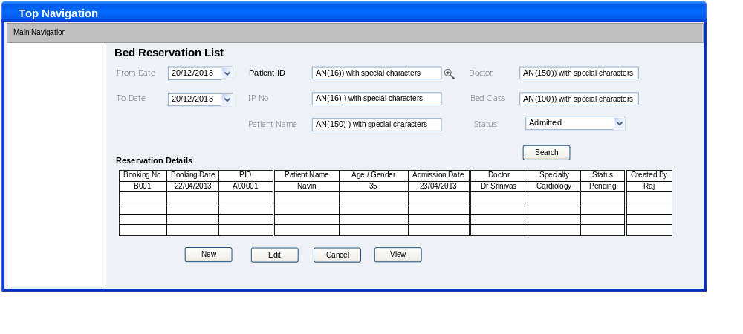

Process Admission
Use Case ID: | UC# FID_ADM_0001_UC _ 001 |  | Feature#: FID_ADM_0001 |  | PRD# :
Use Case Name: | Process Admission
User Story: | ADT staff every day have to process the admission of the patients based on Admission Advice/bed reservation. The patients may have made prior reservation or may have arrived just in time for admissions. The admission advice may contain specific details of admission.. The details of patients to be admitted in the specific shift or day of the ADT staff are available in a list called Admission work list. Concerned ADT staff selects patients from this list as and when patients arrive for admission and process them to ADMIT.
Created By: | Latha Patel | Last Updated By:
Date Created: | Apr 25, 2013 | Date Last Updated:

Actors: | ADT Staff
Description: | All the admission requests / bed reservations are populated in this work list .Admission is done based on the request /reservation
Trigger: | Admission Work List is launched from ADT  Admission screen is launched from the Admission Work List .  Or Directly from the top panel
Preconditions: | Admission advice will be raised (In case admission advice is raised by ADT only confirmed advise shall be displayed) /  Bed reservations may be made  Finance clearance is obtained
Post conditions: | On admission , the details should update the Admission List and Bed Board in the nursing station  By Stander Pass/ Wrist Band / File Number required for Medical Record Creation /Face Sheet configured for admission shall be printed  The alerts shall go to Nursing Station/ Patient Movement Service / House Keeping
Normal Flow: | - ADT Staff (Primary Actor):User searches the Admission Work list for the patient name clicks the admission button  - System Response: Displays Admission screen with the selected patient details  All the relevant data pertaining to admission is captured  Once the details are recorded the outputs pertaining to the Admission like Wrist Band, Visitor or Attainder Pass, Label Generation (for medical Record creation) are printed  If patient is non-registered system alerts the user while selecting from the work list and directs the user to capture registration details  On registration , user needs to capture the admission details
Alternative Flows: | Non listed / walk in patients  - User opens the admission screen . If not registered , user will open the registration screen  - On registration the screen will be closed  - Patient ID and Patient banner will be populated with the patient details  - User needs to capture the admission details
Exceptions: | NA
Includes: | NA
Priority: | High
Frequency of Use: | Frequently used
Business Rules: | Admission Work List  - Admission Work list shall display the current date Admission Requests. / bed reservations  - Once the Admission is done, when the status is completed shall not be shown in the Admission work list but is displayed in the Admission List.  - In case of Booked status on the day of Admission, shall blink the status displayed indicating the Admission is pending for today.  - If the patient has not turned for Admission on the Requested date, the status same shall be communicated to the doctor and patient party through communication channels like SMS, e-mail, etc.  - All Admissions shall be communicated to the doctor, (Nurse) and patient party through communication channels like SMS, e-mail, etc.  - If a doctor wants to change the Admission Date/bed details he needs to edit / cancel the existing Request and he can raise a new request.  If patient does not arrive xxx hours prior to or within xxx hours(App Config) , the admission request gets cancelled .  - The Admission request once cancelled by the Doctor shall update the status as Cancelled in the Admission Work list.  Admission  - If patient is not registered , system shall prompt the user and takes him to the Registration screen . On registering a patient , system shall navigate the user to Admission screen  - If Admission is done based on request / reservation , the details shall be picked up .  - Admissions can be done only for current date  - MLC linkshall be enabled when the MLC check box is selected.  - VIP flow shall be enabled if VIP check box is selected  - Only isolated beds shall be available if Isolation check box is selected (Beds where wards are marked as allow isolation  - If Admission is through the Request the request ward/class details aredisplayed by default which can be further edited. Else user needs to select ward/bed details . If selected ward is gender specific , there shall be an alert message to the user that “This ward is meant for male/female patients only”. If Override option is there for the ward ,user can override and admit the patient . else user needs to select another ward/bed  - If the reserved bed/ward is not available , there shall be an alert message to the user “The reserved bed/ward is not available , do you want to proceed”, if user clicks Yes , then user can proceed.  - Patient category /provisional diagnosis captured for the current encounter shall be displayed  - The blocked beds shall be indicated in different color code The block beds for which override option is there only those beds shall be available . When user selects such beds , system should display a message “This bed is blocked Do you want to proceed”  - Under the Billing Details,deposit amount is displayed based on patient class , Tariff Category and bed class. On saving auto deposit request is raised and shall be available in Receipts and Payments Work List  - Till the Bill generation account details can be changed. Till the Bill generation, payers can be added.  - All fields under the NOK/ Referral Details are editable.  - Admissions can be done with or without request.  - Duplicate “patient admission” is not allowed  - Provision is also given where the default Billing Bed Class and admitted bed class is captured  - .User needs to capture patient consent regarding bed class change and upload consent documents  - Episode details are also captured at the Time of Admission. If any previous episode exists the previous episode button/link is enabled and click on the button provides the episode details as in below screen  Only the open episodes should be available for the user to select. Select the required episode .  - If admission is pertaining to the existing episode double click on the grid shall display the episode details in the related fields of Admission and the next Encounter No. is calculated and displayed.  - Once the details are recorded the outputs pertaining to the Admission like Face Sheet, Wrist Band, Visitor Pass, Label Generation (for medical Record creation) are printed  - Isolated beds shall not be available for selection . It should be available only if isolation check box is selected  - Billing Bed class to be populated based on Patient Class (App .Config)..  Admitting Bed Class to be populated with all the bed classes  - Assigning Multiple Doctors , Maternity Check Box and Medicine on Cash fields are only for Jaslok Requirements . For product these are not required .There shall be configurable option to display /not to display these fields  Select the doctors from the help screen. Clicking on Add will add the doctor to the grid .  Maternity check box shall be enabled only for female patients  - If age is above or equal to 60 . Senior citizen proof submitted “Yes “/ “No” buttons shall be enabled , and prompts to select either Yes / No  This is only Jaslok Requirement  - Type of attachments can be .xls,.pdf,.doc etc  Patient Category :If patient category is selected as “Staff “/ “Staff Dependent “,  System shall check these details are captured as part of registration or not , if not system shall prompt the message to capture the details with Yes/ No options  If user clicks on Yes , the staff details section of registration shall be displayed (Edit Registration screen shall be displayed) . On capturing the details , user shall be navigated back to Admission screen,  If user click No , patient category should be defaulted to Select  If Patient Category is selected as Sponsor System shall check these details are captured as part of registration or not  If not system shall prompt the message to capture the details with Yes/ No options  If user clicks Yes , the Sponsor details section of registration shall be displayed (Edit Registration screen shall be displayed) . On capturing the details , user shall be navigated back to Admission Screen  If user click No , patient category should be defaulted to Select  If patient category is insurance “Insurance Details “ pop up screen shall be displayed . user can select the existing insurance details or he can Add new insurance  On clicking Add , insurance details section of registration will be displayed .  User can capture the insurance details . on capturing , insurance details are populated in pop up screen with a facility to check  On selecting , the system navigates the user to Admission screen and insurance plan name will be displayed  The insurance Plan field will be enabled only in Patient Category is insurance  If no insurance is available , Insurance Pop up screen will not be displayed  Directly user shall be navigated to insurance details section of resgistration  ( Edit Registration screen shall be displayed)  Referral Details  If user click Referred By search , the “Referral Search” will be displayed  All the facilities are displayed left side  Select the facility and click on Plus icon. (Plus icon will be there only if departments are available)  All the departments within the facility will be displayed . Click on Plus icon . All the sub departments within the departments are displayed  Select the sub department and click on Plus icon , All the doctors within the Sub department are displayed . Select the doctor and click on Accept button  The search screen will be closed and selected value will be displayed in the Referred by field  Plus icon will be available only if related sub sections are available  In the Referred BY field , If user selects only facility , the facility name ill be displayed  If user selects doctor then Facility name – Department Name – Sub Department Name – Doctor Name will be displayed
Special Requirements: | Admission and Bed Reservation Work List  Search Fields : From and To dates (Selection)  Patient ID – Selection from the help screen  Patient Name - Entry  Doctor - Entry  Advice details and Bed Reservation Details  Grid – Non editable. Details are displayed based on the search criteria  Admission  Admission based on advice and reservation  Patient ID and Patient Details – Non Editable . Displayed based on the selected record in the work list  Request No – Text Box - Non Editable - Displayed if advice is selected  Booking ID –Text Box - Non Editable – Displayed if reservation is selected  Admission date / Time – Non editable – Displayed based on the selected advice / reservation  Admission Type : Displayed based on the selected advice . Else can be selected  Admission Source – Combo - Selection from masters  Hospital service – Combo Box - Displayed based on advice . . Else can be selected/ edited  Sub Service –Combo Box - Selection – This drop down list is populated based on hospital service  Provisional Diagnosis – Selection from masters – Displayed based on advice  Chief Complaints : Displayed based on selected advice . it can be edited further  Expected LOS – Displayed based on advice /reservation It can be edited /entered  Expected Date of Discharge - Displayed based on advice /reservation if LOS is edited , it is changed accordingly  Admitting Doctor : Displayed based on advice /reservation It can be edited /selected  Specialty – Non Editable – Displayed based on the selected doctor  Primary Consultant – By default admitting doctor is displayed . user can edit this  Specialty – Non Editable – Displayed based on the primary consultant  Assigning Doctors :Selection from the help screen. Clicking on Add will add the doctor to the grid below .  Grid Details : Non editable  Episode Details :  Episode No - Non Editable –Displayed on page load . Can be selected from  Previous episodes  Episode Description – Displayed if selected from previous episodes. Else it is entry field  Encounter No – Non Editable  Assign Bed –  Billing Bed Class : Displayed if captured during bed reservation . Further it can be edited .( Bed classes are populated based on patient class . App .Config)  Nursing Station:Displayed if captured in the reservation . It can be further selected (Nursing Station is populated based on Bed Class)  Admitted Bed Class : Displayed based on billing bed class .Further it can be edited  Charges Posted on : Selection from one of the options  Ward :Displayed if captured in the reservation . It can be further selected. (Wards are populated based on Nursing Station )  Grid Details : Displayed based on the selected ward . Non editable  Bed No Displayed based on the selection in the grid  Additional Details  Ambulatory Status : Selection from masters  Mode of Arrival : Selection from masters  Maternity : Checkbox selection  Expected Due Date : Selection from date picker  Medicine on Cash : Checkbox selection  Patient Valuables : Entry  For Walk in Patients  Patient ID : Selection from patient Search  Patient Banner : Non Editable – Details are displayed based on the selected patient  Admission date / Time – Selection from date picker  Admission Type : Selection from masters  Admission Source – Selection from masters  Hospital service – Selection from masters  Sub Service – Selection – This drop down list is populated based on hospital service  Provisional Diagnosis – Selection from masters  Chief Complaints : Entry  Expected LOS – Entry  Expected Date of Discharge - Selection from date picker  Admitting Doctor : Selection from masters  Specialty – Non Editable – Displayed based on the selected doctor  Assigning Doctors : Selection from the help screen  Grid Details : Non editable  Episode Details :  Episode No - Non Editable –Displayed on page load . Can be selected from  Previous episodes  Episode Description – Displayed if selected from previous episodes. Else it is entry field  Encounter No – Non Editable  Assign Bed –  Billing Bed Class Selection from masters- (Populated based on Patient Class. App Configuration)  Allow All Bed Classes- Check Box Selection will populate all the available bed classes in the Billing Bed and Admitted Bed Class  Nursing Station:Selection from masters- It is populated based on selected bed class)  Admitted Bed Class : Displayed based on billing bed class .Further it can be edited  Charges Posted on : Selection from one of the options  Ward : Selection : This is populated based on Nursing Station and Bed Class  Grid Details : Displayed based on the selected ward . Non editable  Bed No Displayed based on the selection in the grid  Additional Details  Ambulatory Status : Selection from masters  Mode of Arrival : Selection from masters  Maternity : Checkbox selection  Expected Due Date : Selection from date picker  Medicine on Cash : Checkbox selection  Patient Valuables : Entry
Assumptions: | NA
Notes and Issues:
(NFR #List) Non-functional Requirements | NA
Screen Name with Pattern Mapping | Admission Work List – UIP08 and Patient Search UIP04  Admission –UIP13 and Patient Search UIP04
Messages (Error / Status Messages ) | - Status Messages – On Save - Record inserted /updated successfully  - If the reserved bed/ward is not available , there shall be an alert message to the user “The reserved bed/ward is not available , do you want to proceed”, if user clicks Yes , then user can proceed.  - “This bed is blocked Do you want to proceed”  - If selected ward is gender specific , there shall be an alert message to the user that “This ward is meant for male/female patients only”.  - Patient is not registered , Register the patient  Error Messages –on Save - Record Not inserted /updated
Break crumb Details | Home - ADT – Admission Work List  Home – ADT – Admission Work List – Admission  Home – ADT - Admission
Collapsible Panels | Next of Kin Details ( The details are captured in the registration ) Same details shall be shown on Panel expansion  MLC Details :  Referral Details ( The details are captured in the registration ) Same details shall be shown on Panel expansion  Attachments :  Billing Details : ( The details are captured in the registration ) Same details shall be shown on Panel expansion  Additional Details  Patient Valuables
Configurable Fields (Display / Not to Display) | For Walk in Patients  Request No and Booking ID will not be displayed  Expected Due Date is displayed only if Maternity is checked

Admission Work List
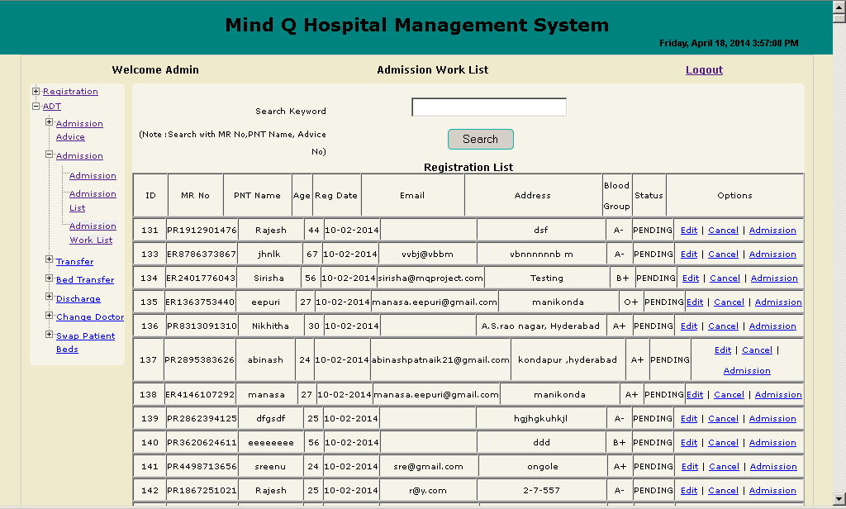

From Work List – Process Admission (If Close back to work list. On Save Admission List)
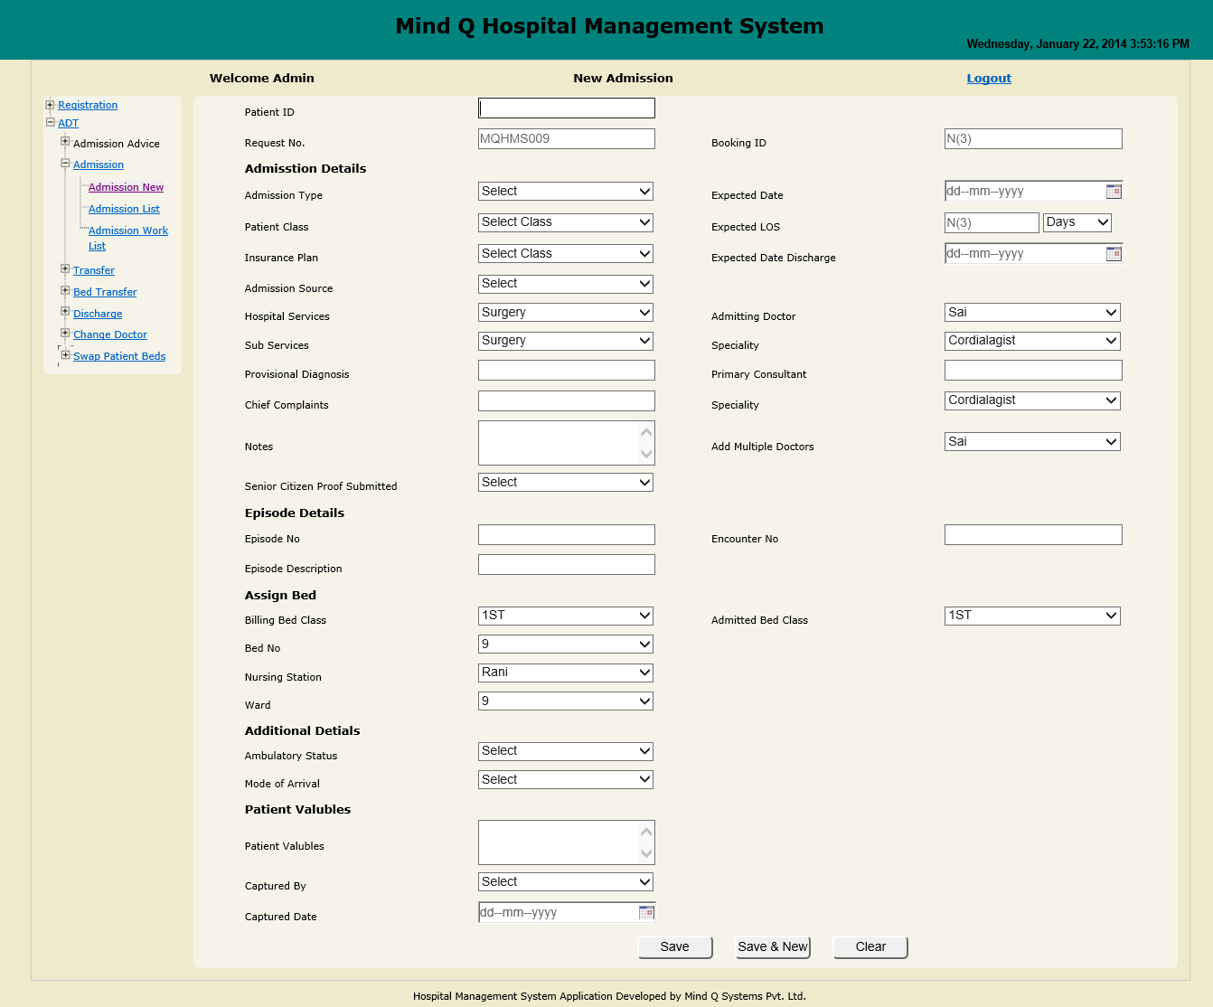

Previous Episode Descriptions 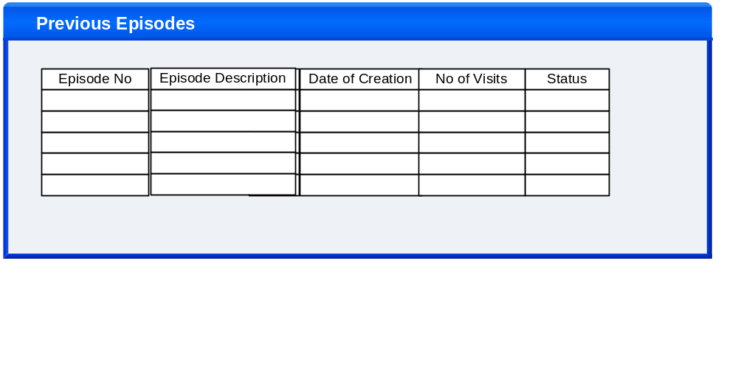

If Patient Category is Insurance
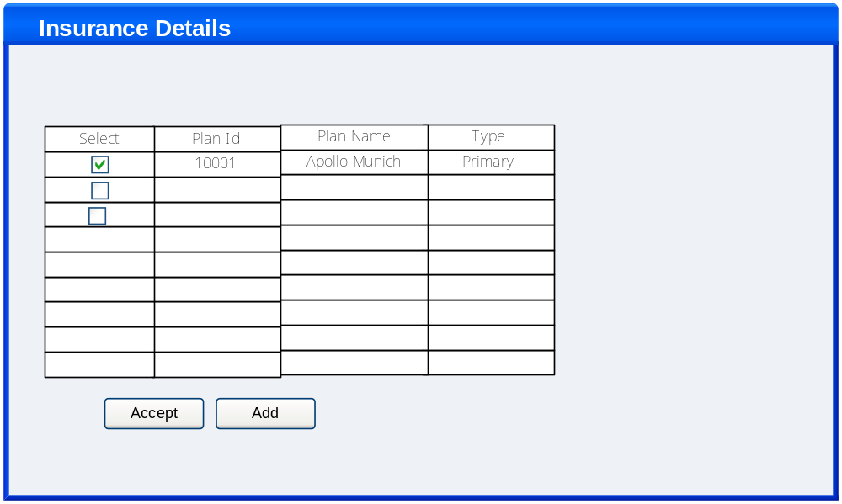

Referral Search

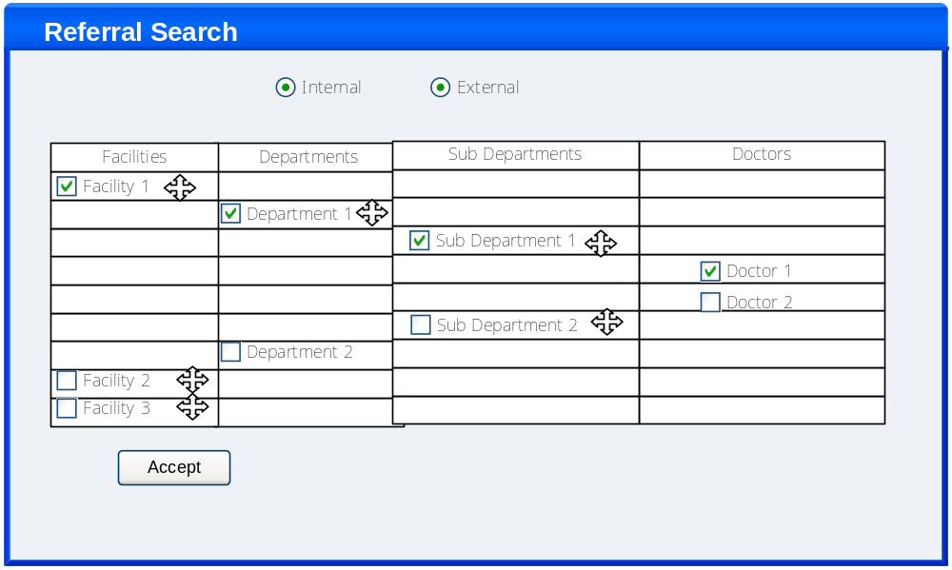

Edit/Cancel/View Admission

Use Case ID: | UC# FID_ADM_0001_UC _ 002 |  | Feature#: FID_ADM_0001 |  | PRD# :
Use Case Name: | Edit / Cancel /View Admissions
User Story: | Patient wants to cancel admission details
Created By: | Latha Patel | Last Updated By:
Date Created: | Apr 26, 2013 | Date Last Updated:

Actors: | ADT Staff
Description: | This process displays all the created admissions . Allows to edit/cancel /view admission
Trigger: | Admission List is launched from top panel
Preconditions: | Admission should have been done
Post conditions: | Admission details shall be updated and displayed in the Admission list after edit/cancel
Normal Flow: | ADT Staff(Primary Actor): Selects the patient and clicks on Edit  System Response: Opens patient Admission record in Edit mode  ADT Staff(Primary Actor):make the necessary changes and click Update  System: Saves and updates the record.
Alternative Flows:
Exceptions:
Includes: | NA
Priority: | High
Frequency of Use: | Frequently used
Business Rules: | - List shall display only the current day Admissions on page load and.  - Selection of the row and click on the Edit button shall allow to edit the Admission details  - If any service is raised , user cannot edit ward/bed details  - Admission Date , Ward/Bed details cannot bed edited , if admission is done based on reservation  Selection of the row in the list and click on the Cancel shall display the screen in cancel mode to capture the Reason for Cancellation, (Cancellation indicated by different colour code-complete row  On cancellation , The status of the record in Admission Advice / Admission Work List is changed to Pending. The status of allocated ward/beds shall change to Previous Status  - If the details are updated, the pop up message shows updated successfully and Click on Ok  - Admission is allowed for cancellation only when no request is raised for the patient  - Once the patient is discharged, the Admission details cannot be updated.
Special Requirements: | Admission List  Search Fields : From and To dates (Selection)  Patient ID – Selection from the help screen  IP No – Entry  Patient Name - Entry  Doctor - Entry  Admitted Details  Grid – Non editable. Details are displayed based on the search criteria  Admission  Details are picked up based on selected patient  Patient ID and Patient Details – Non Editable . Displayed based on the selected record in the work list  Request No – Non Editable - Displayed if admission is based on advice  Booking ID – Non Editable – Displayed if admission is based on reservation  Admission date / Time – Non editable- if admission is done based on advice/reservation  Admission Type : Displayed based on the selected record . It can be edited  Admission Source – Displayed based on the selected record . It can be edited  Hospital service – Displayed based on the selected record . It can be edited  Sub Service – Displayed based on the selected record . It can be edited Provisional Diagnosis – Displayed based on the selected record Non editable  Chief Complaints :Displayed based on the selected record . It can be edited further  Expected LOS – Displayed based on the selected record . It can be edited Expected Date of Discharge - Displayed based on the selected record . It can be edited and if LOS is changed it should be changed accordingly  Admitting Doctor :Displayed based on the selected record . It can be edited Specialty – Non Editable – Displayed based on the selected doctor  Assigning Doctors :Displayed based on the selected record . It can be edited  Grid Details : Non editable  Episode Details :  Episode No - Non Editable –Displayed on page load . Can be selected from  Previous episodes  Episode Description – Displayed if selected from previous episodes. Else it is entry field  Encounter No – Non Editable  Assign Bed –  Billing Bed Class : Displayed based on the selected record . It can be edited only if allocated bed is not according to reservation  Nursing Station:Displayed based on the selected record . It can be edited only if allocated bed is not according to reservation  Admitted Bed Class : It can be edited only if allocated bed is not according to reservation  Charges Posted on : Selection from one of the options  Ward : It can be edited only if allocated bed is not according to reservation  Grid Details : Displayed based on the selected ward . Non editable  Bed No – Non Editable  Additional Details  Ambulatory Status : Selection from masters  Mode of Arrival : Selection from masters  Maternity : Checkbox selection  Expected Due Date : Selection from date picker  Medicine on Cash : Checkbox selection  Patient Valuables : Entry  Cancel Mode
Assumptions: | NA
Notes and Issues:
(NFR #List) Non-functional Requirements | NA
Screen Name with Pattern Mapping | Admission List – UIP08 and Patient Search UIP04  Admission in edit mode – UIP13  Admission in Cancel Mode – UIP13  Admission in View Mode– UIP13
Messages (Error / Status Messages ) | Status Messages – On Save - Record inserted /updated successfully  Error Messages –on Save - Record Not inserted /updated
Break crumb Details | Home - ADT – Admission List  Home – ADT – Admission List – Admission in edit mode
Collapsible Panels | Next of Kin Details ( The details are captured in the registration ) Same details shall be shown on Panel expansion  MLC Details :  Referral Details ( The details are captured in the registration ) Same details shall be shown on Panel expansion  Attachments :  Billing Details : ( The details are captured in the registration ) Same details shall be shown on Panel expansion  Additional Details  Patient Valuables
Configurable Fields (Display / Not to Display) | For Walk in Patients  Request No and Booking ID will not be displayed

Admission List
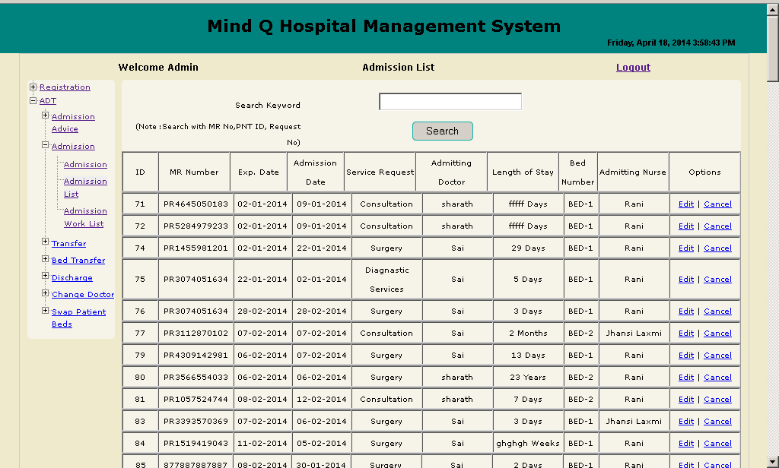

End………………..

